**Malala’s Story**

Cut out and stick these events from Malala Yousafzai’s life in the correct order.

**twinkl.com**

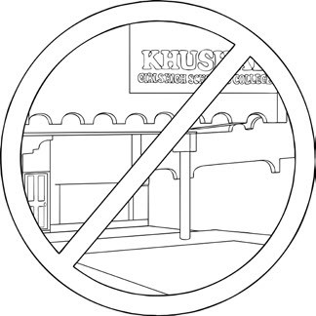

The Taliban started to take over the Swat

Valley, where she lived, and they banned

girls from going to school.

**twinkl.com**

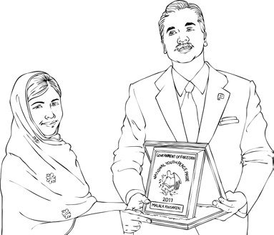

In 2011, Malala won Pakistan’s National

Youth Peace Prize for speaking out about

how every girl should have an education.

**twinkl.com**

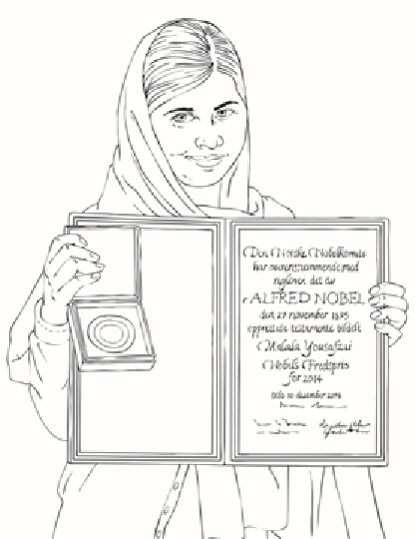

In 2014, Malala became the youngest

person to win the Nobel Peace Prize.

Malala set up the Malala Fund, a

charity that campaigns for the right to an

education for every girl across the world.

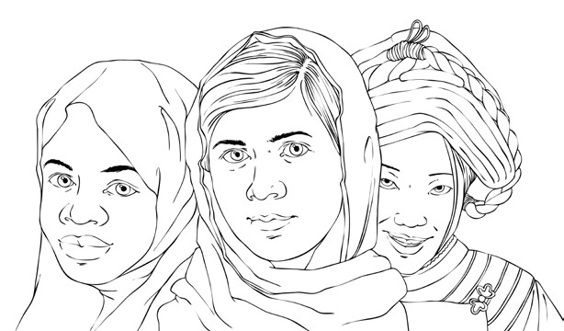

**twinkl.com**

**twinkl.com**

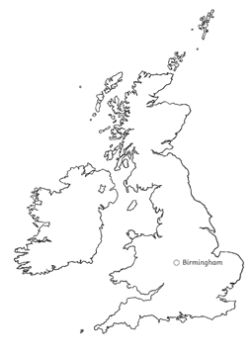

She was taken to hospital in Peshawar,

Pakistan and then moved to Birmingham,

England to receive further care.

**twinkl.com**

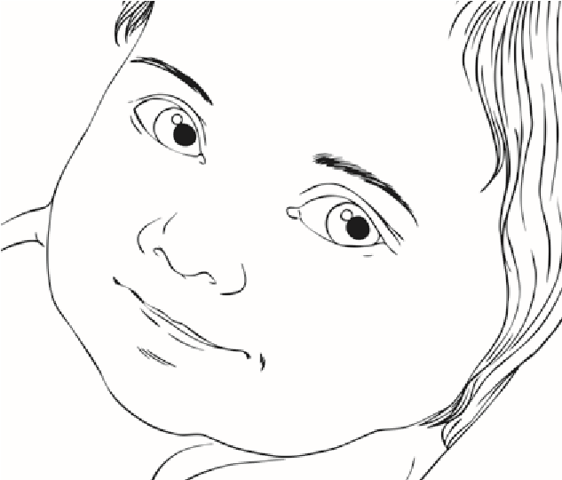

Malala was born on 12th July, 1997.

Her father set up schools in Pakistan and

Malala attended one.

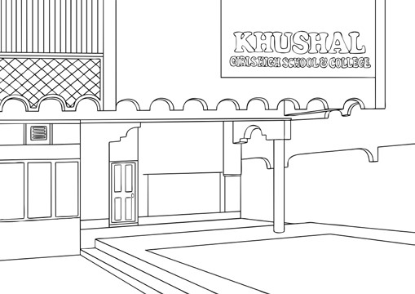

**twinkl.com**

**twinkl.com**

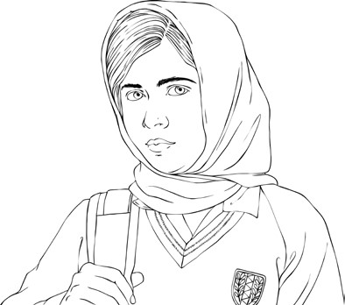

In 2013, Malala recovered but it was not

safe for her to return to Pakistan so she

started going to school in the UK.

**twinkl.com**

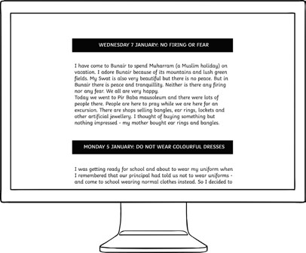

In 2009, Malala started to write a

blog about how she was being denied

an education.

The Taliban threatened her but she

continued to go to school.

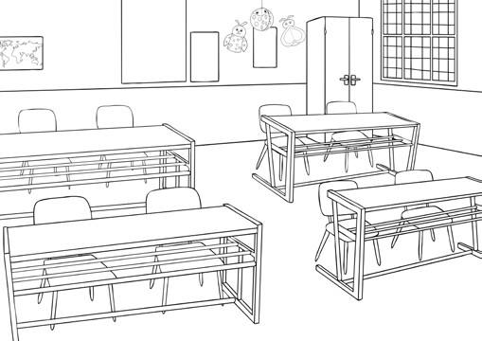

**twinkl.com**

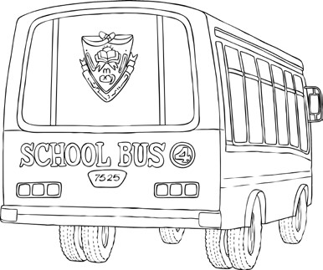

**twinkl.com**

On 9th October, 2012, the Taliban stopped

the school bus taking her home from

school and shot her.