Viking Invasions
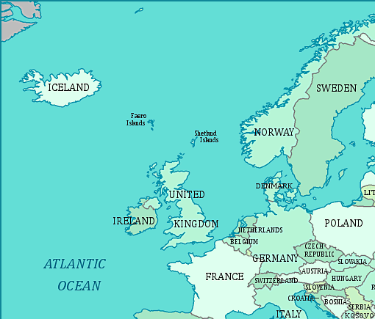
Draw lines with arrows to show me where the Vikings came from and where they invaded.

